NAME – Satish Kumar
Roll No - 244ca046
Assignment No- 5
MCA 2 semester
DBMS LAB

1.Create the following tables with the following attributes and constraints on them.
a. Bank (bk_code, bk_name, bk_address)
b . Branch (br_id, br_name, br_address, bk_code)
c. Customer (cust_ID, cust_name, phone_no, address)
d. Account (acc_no, acc_type, balance, br_id)
e. Customer_Account (cust_ID, acc_no)
f. Loan (loan_ID, loan_type, amount, br_id)
g. Customer_Loan (cust_ID, loan_ID)

Create all the tables by defining primary key, foreign key and other appropriate constraints

CREATE TABLE Bank (
bk_code NUMBER PRIMARY KEY,
bk_name VARCHAR2(255) NOT NULL,
bk_address VARCHAR2(255) NOT NULL
);

Branch Table-

CREATE TABLE Branch (
br_id VARCHAR2(10) PRIMARY KEY,
br_name VARCHAR2(255) NOT NULL,
br_address VARCHAR2(255) NOT NULL,
bk_code NUMBER NOT NULL REFERENCES Bank(bk_code) ON DELETE CASCADE
);

Customer Table--

CREATE TABLE Customer (
cust_ID NUMBER PRIMARY KEY,
cust_name VARCHAR2(255) NOT NULL,
phone_no VARCHAR2(20) NOT NULL,
address VARCHAR2(255) NOT NULL
);

Account Table--

CREATE TABLE Account (
acc_no NUMBER PRIMARY KEY,
acc_type VARCHAR2(50) NOT NULL,
balance NUMBER(10,2) NOT NULL,
br_id VARCHAR2(10) NOT NULL REFERENCES Branch(br_id) ON DELETE CASCADE
);

Customer_Account Table --

CREATE TABLE Customer_Account (
cust_ID NUMBER REFERENCES Customer(cust_ID) ON DELETE CASCADE,
acc_no NUMBER REFERENCES Account(acc_no) ON DELETE CASCADE,
PRIMARY KEY (cust_ID, acc_no)
);

Loan Table --

CREATE TABLE Loan (
loan_ID NUMBER PRIMARY KEY,
loan_type VARCHAR2(50) NOT NULL,
amount NUMBER(10,2) NOT NULL,
br_id VARCHAR2(10) NOT NULL REFERENCES Branch(br_id) ON DELETE CASCADE
);

Customer_Loan Table --

CREATE TABLE Customer_Loan (
cust_ID NUMBER REFERENCES Customer(cust_ID) ON DELETE CASCADE,
loan_ID NUMBER REFERENCES Loan(loan_ID) ON DELETE CASCADE,
PRIMARY KEY (cust_ID, loan_ID)
);

2. Insert atleast five records in each table.

INSERT INTO Bank (bk_code, bk_name, bk_address) VALUES (1, 'SBI', 'Mumbai, MH');
INSERT INTO Bank (bk_code, bk_name, bk_address) VALUES (2, 'PNB', 'New Delhi, DL');
INSERT INTO Bank (bk_code, bk_name, bk_address) VALUES (3, 'HDFC', 'Mumbai, MH');
INSERT INTO Bank (bk_code, bk_name, bk_address) VALUES (4, 'ICICI', 'Gurugram, HR');
INSERT INTO Bank (bk_code, bk_name, bk_address) VALUES (5, 'AXIS', 'Mumbai, MH');
INSERT INTO Bank (bk_code, bk_name, bk_address) VALUES (6, 'BOB', 'Vadodara, GJ');
INSERT INTO Bank (bk_code, bk_name, bk_address) VALUES (7, 'Kotak', 'Mumbai, MH');
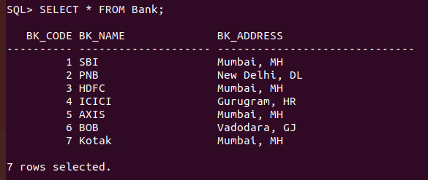

INSERT INTO Branch (br_id, br_name, br_address, bk_code) VALUES ('BR001', 'SBI Fort', 'Fort, Mumbai', 1);
INSERT INTO Branch (br_id, br_name, br_address, bk_code) VALUES ('BR002', 'PNB CP', 'Connaught Pl, Delhi', 2);
INSERT INTO Branch (br_id, br_name, br_address, bk_code) VALUES ('BR003', 'HDFC CGT', 'Churchgate, Mumbai', 3);
INSERT INTO Branch (br_id, br_name, br_address, bk_code) VALUES ('BR004', 'ICICI Sec 42', 'Sec 42, Gurugram', 4);
INSERT INTO Branch (br_id, br_name, br_address, bk_code) VALUES ('BR005', 'AXIS Andheri', 'Andheri, Mumbai', 5);
INSERT INTO Branch (br_id, br_name, br_address, bk_code) VALUES ('BR006', 'BOB Sayajigunj', 'Vadodara, GJ', 6);
INSERT INTO Branch (br_id, br_name, br_address, bk_code) VALUES ('BR007', 'Kotak NP', 'Nariman Point, Mumbai', 7);
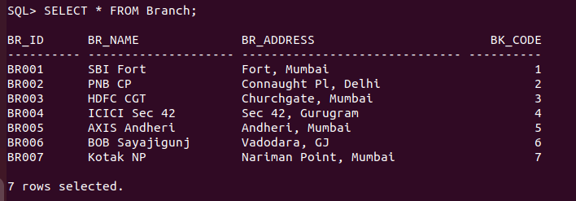

INSERT INTO Customer (cust_ID, cust_name, phone_no, address) VALUES (1, 'Amit', '9876543210', 'Mumbai, MH');
INSERT INTO Customer (cust_ID, cust_name, phone_no, address) VALUES (2, 'Ravi', '9876543211', 'Delhi, DL');
INSERT INTO Customer (cust_ID, cust_name, phone_no, address) VALUES (3, 'Priya', '9876543212', 'Mumbai, MH');
INSERT INTO Customer (cust_ID, cust_name, phone_no, address) VALUES (4, 'Neha', '9876543213', 'Gurugram, HR');
INSERT INTO Customer (cust_ID, cust_name, phone_no, address) VALUES (5, 'Vikash', '9876543214', 'Mumbai, MH');
INSERT INTO Customer (cust_ID, cust_name, phone_no, address) VALUES (6, 'Sandeep', '9876543215', 'Vadodara, GJ');
INSERT INTO Customer (cust_ID, cust_name, phone_no, address) VALUES (7, 'Anjali', '9876543216', 'Mumbai, MH');

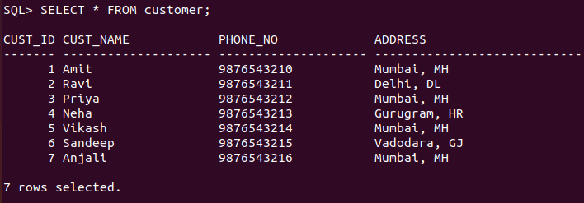
INSERT INTO Account (acc_no, acc_type, balance, br_id) VALUES (1001, 'Saving', 50000.00, 'BR001');
INSERT INTO Account (acc_no, acc_type, balance, br_id) VALUES (1002, 'Current', 100000.00, 'BR002');
INSERT INTO Account (acc_no, acc_type, balance, br_id) VALUES (1003, 'Saving', 75000.00, 'BR003');
INSERT INTO Account (acc_no, acc_type, balance, br_id) VALUES (1004, 'Fixed', 200000.00, 'BR004');
INSERT INTO Account (acc_no, acc_type, balance, br_id) VALUES (1005, 'Saving', 25000.00, 'BR005');
INSERT INTO Account (acc_no, acc_type, balance, br_id) VALUES (1006, 'Current', 50000.00, 'BR006');
INSERT INTO Account (acc_no, acc_type, balance, br_id) VALUES (1007, 'Fixed', 150000.00, 'BR007');
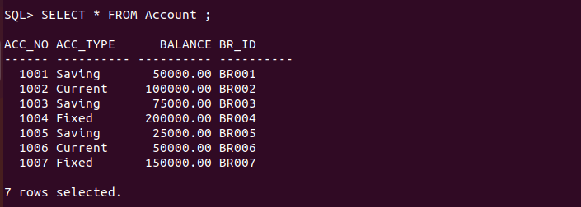

INSERT INTO Customer_Account (cust_ID, acc_no) VALUES (1, 1001);
INSERT INTO Customer_Account (cust_ID, acc_no) VALUES (2, 1002);
INSERT INTO Customer_Account (cust_ID, acc_no) VALUES (3, 1003);
INSERT INTO Customer_Account (cust_ID, acc_no) VALUES (4, 1004);
INSERT INTO Customer_Account (cust_ID, acc_no) VALUES (5, 1005);
INSERT INTO Customer_Account (cust_ID, acc_no) VALUES (6, 1006);
INSERT INTO Customer_Account (cust_ID, acc_no) VALUES (7, 1007);



INSERT INTO Loan (loan_ID, loan_type, amount, br_id) VALUES (1, 'Home Loan', 500000.00, 'BR001');
INSERT INTO Loan (loan_ID, loan_type, amount, br_id) VALUES (2, 'Personal Loan', 100000.00, 'BR002');
INSERT INTO Loan (loan_ID, loan_type, amount, br_id) VALUES (3, 'Car Loan', 300000.00, 'BR003');
INSERT INTO Loan (loan_ID, loan_type, amount, br_id) VALUES (4, 'Education Loan', 200000.00, 'BR004');
INSERT INTO Loan (loan_ID, loan_type, amount, br_id) VALUES (5, 'Home Loan', 700000.00, 'BR005');
INSERT INTO Loan (loan_ID, loan_type, amount, br_id) VALUES (6, 'Personal Loan', 150000.00, 'BR006');
INSERT INTO Loan (loan_ID, loan_type, amount, br_id) VALUES (7, 'Car Loan', 400000.00, 'BR007');
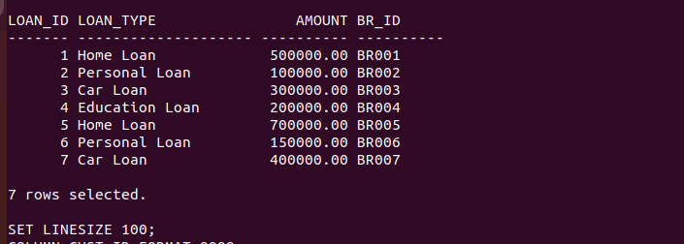

INSERT INTO Customer_Loan (cust_ID, loan_ID) VALUES (1, 1);
INSERT INTO Customer_Loan (cust_ID, loan_ID) VALUES (2, 2);
INSERT INTO Customer_Loan (cust_ID, loan_ID) VALUES (3, 3);
INSERT INTO Customer_Loan (cust_ID, loan_ID) VALUES (4, 4);
INSERT INTO Customer_Loan (cust_ID, loan_ID) VALUES (5, 5);
INSERT INTO Customer_Loan (cust_ID, loan_ID) VALUES (6, 6);
INSERT INTO Customer_Loan (cust_ID, loan_ID) VALUES (7, 7);

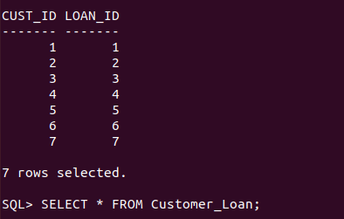

3. List the details of all customers.

4. Find the cust_ID and phone number of customer ‘Ravi’.
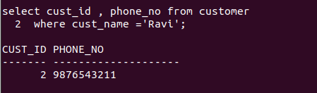
5. Find the Address of all branches of br001.

6. Find the details of Customer having ID 1.

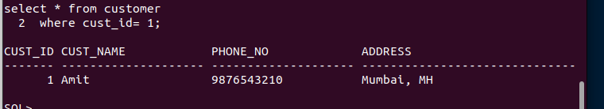
7. List the account details having balance more than 10000.


8. List the account details of branch br001.

9. List the loan details of branch br001.


10. List the account details with their branch address.
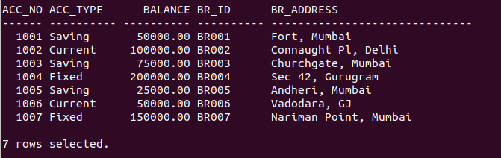

11. List the customer details with their account details.

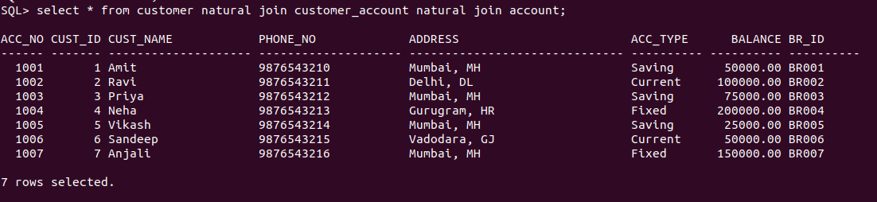
12. List the customer details having account type ‘savings’.

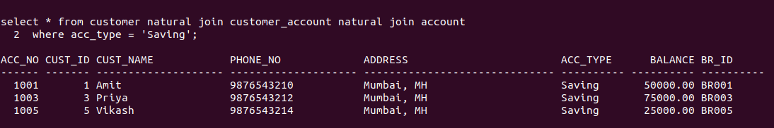
13. List the customer details having vehicle loan.

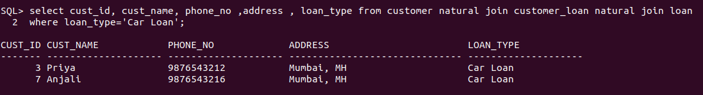

14. List the branch names of all accounts.


15. List the customer details going to ‘SBI Fort’ branch.

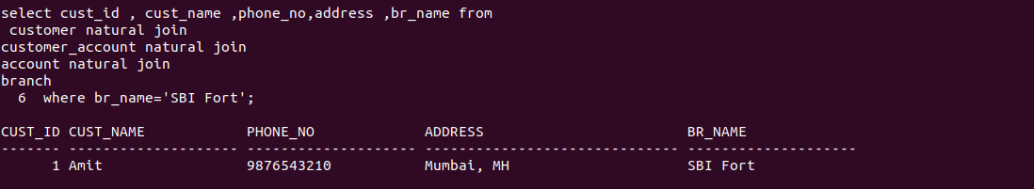
16. List the customers having loan account in 'ICICI Sec 42' branch.



17. Find the customers having balance between 1000 to 100000 .

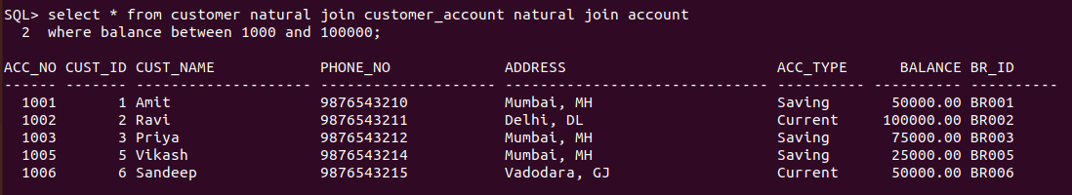

18. Give a bonus of rupees 100 to customers having more than 10000 balance.


19. Deduct 50 rupees from customers having less than 500 rupees in balance.


20. Give the customer details having home loan


21. Give the customer details having home loan in ‘NITK’ branch.

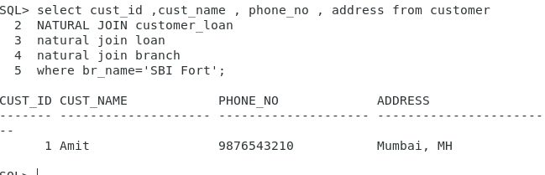

22. Add a column NOMINEE to the customer table with data type varchar (30).

ALTER TABLE Customer ADD NOMINEE VARCHAR2(50);

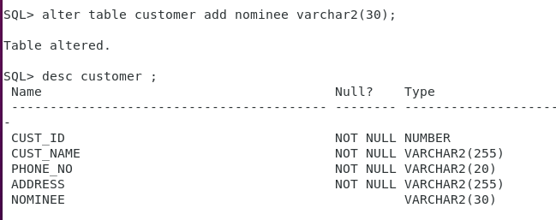
23. List all the account numbers in ascending order of their balance.

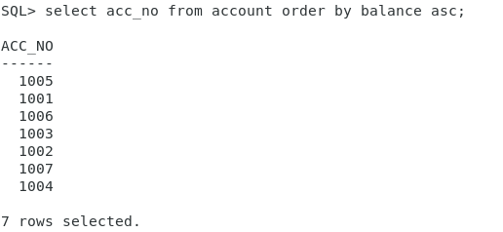
SELECT acc_no FROM Account ORDER BY balance;

24. Count the number of customers having account type savings.

SELECT COUNT(DISTINCT cust_ID)
FROM Customer_Account
NATURAL JOIN Account
WHERE acc_type = 'Savings';

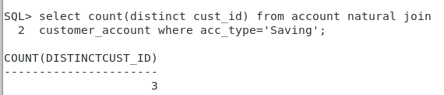
25. Count the number of customers for each account type.

SELECT acc_type, COUNT(DISTINCT cust_ID)
FROM Customer_Account
NATURAL JOIN Account
GROUP BY acc_type;
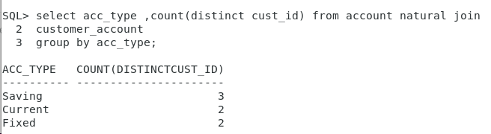

26. Find the total balance in Savings account.

SELECT SUM(balance)
FROM Account
WHERE acc_type = 'Saving';

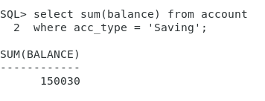
27. Find the average balance of Current account.

SELECT AVG(balance)
FROM Account
WHERE acc_type = 'Current';

28. Find the average balance for each account type.

SELECT acc_type, AVG(balance)
FROM Account
GROUP BY acc_type;

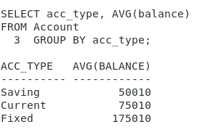
29. Find the customer details having maximum balance.

SELECT Customer.*
FROM Customer
NATURAL JOIN Customer_Account
NATURAL JOIN Account
WHERE balance = (SELECT MAX(balance) FROM Account);

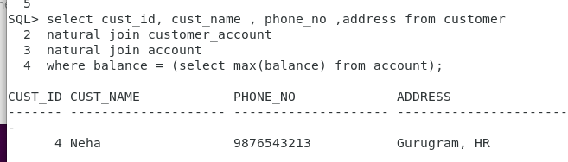
30. Find the average amount for vehicle loan.

SELECT AVG(amount)
FROM Loan
WHERE loan_type = 'Vehicle Loan';
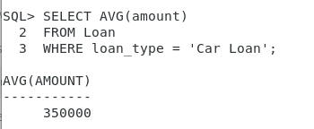
31. Find the average balance in each branch.

SELECT br_name, AVG(balance)
FROM Account
NATURAL JOIN Branch
GROUP BY br_name
